**Abstract**

In today, Aids is still a serious disease that many people think it is incurable. Many patients need to use drugs to control the disease, so our group project topic is to discuss the effects of race and Heroin/Cocaine Use to the time return to drug use. We have 628 observations and will use Cox Hazard proportional model.

**Sources and Background Information**

Description of the variables in the UIS Study described in Table 1.3

 of Hosmer, D.W. and Lemeshow, S. and May, S. (2008) Applied Survival

 Analysis: Regression Modeling of Time to Event Data: Second Edition,

John Wiley and Sons Inc., New York, NY.

The dataset of the book is from University of Massachusetts Aids Research Unit Impact Study.

We have 12 variable in the data set

Variables:

1. ID (Identification Code): the identification code is range from 1 – 628.

2. Age (Age at Enrollment): the unit of age is in Years

3. Beck (Beck Depression Score at Admission): the score is range from 0 to 54

4. Hercoc (Heroin/Cocaine Use During 3 Months Prior to Admission): code as 1 = Heroin & Cocaine, 2 = Heroin Only, 3 = Cocaine Only, 4 = Neither Heroin nor Cocaine

5. Ivhx (IV Drug Use History at Admission): code as 1 = Never, 2 = Previous, 3 = Recent

6. Ndrugtx (Number of Prior Drug Treatments) : number ranged from 0 to 40

7. race (Subject's Race): code as 0 = White, 1 = Other

8. treat (Treatment Randomization Assignment): code as 0 = Short, 1 = Long

9. site (Treatment Site): code as 0 = A, 1 = B

10. los (Length of Treatment Measured from Admission): unit in Days

11. time (Time to Return to Drug Use Measured from Admission): unit in Days

12. censor (Returned to Drug Use): code as 1 = Returned to Drug Use, 0 = Otherwise

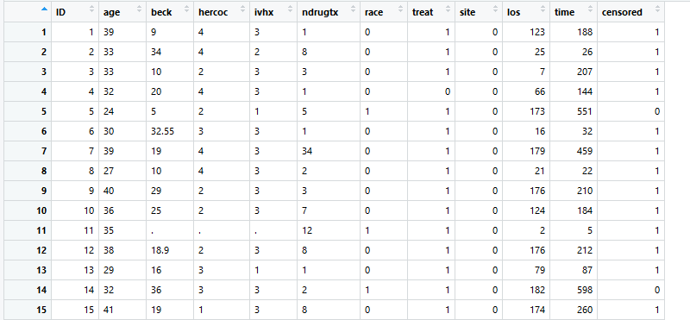

**Research Question:**

We are interested in whether difference between race, treatment random assigned, or site would have significant influence on time from treatment to return to drug use. In addition, we want to see if there is any interaction between any of these covariates: treat, race and site.

**KM plots for 3 variables:**

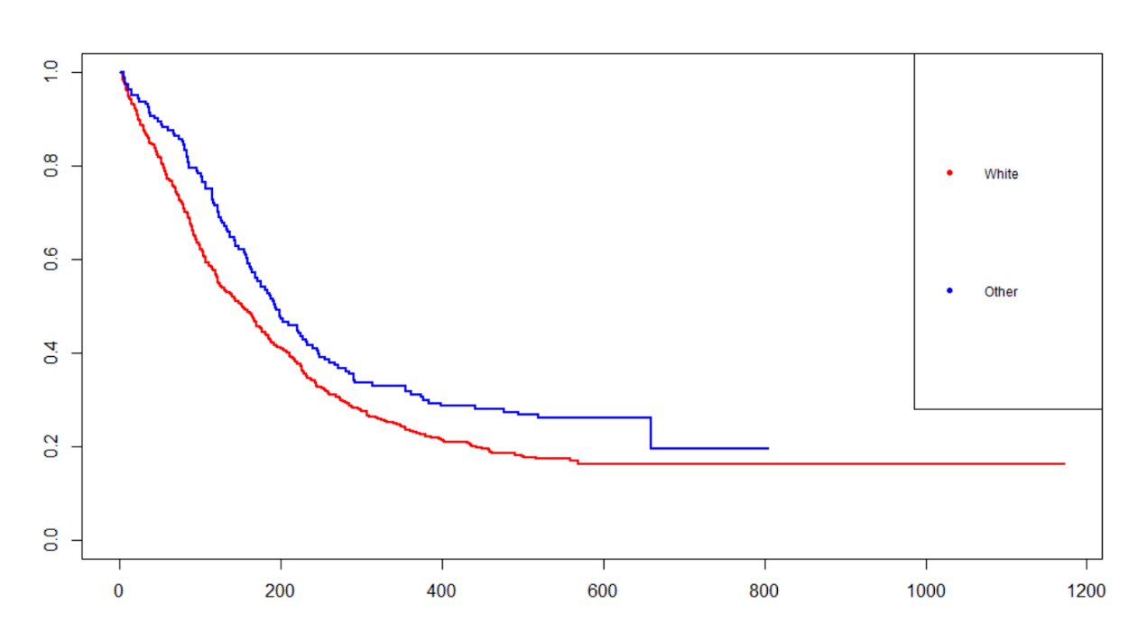

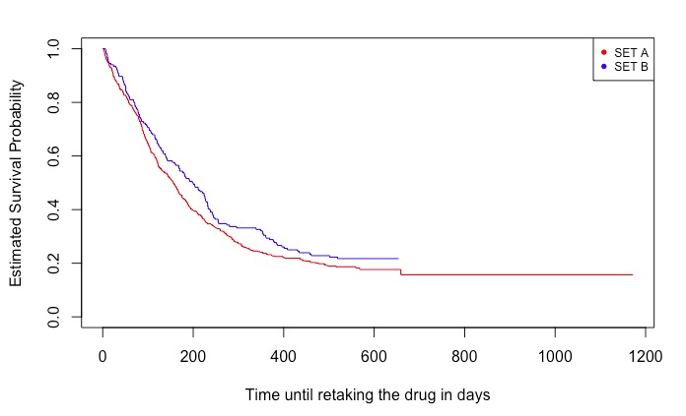

We use log-log plot to check if the variable satisfy the PH assumptions:

